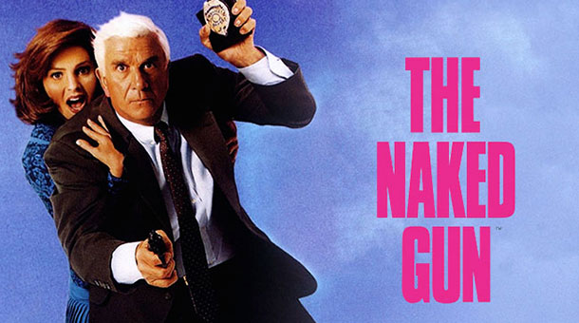
The Naked Gun: From the files of Police Squad!

Name: ………………………………………………………………

- Watch the video and fill in the words that are missing.

1. |  |  | 19.
2. |  |  | 20.
3. |  |  | 21.
4. |  |  | 22.
5. |  |  | 23.
6. |  |  | 24.
7. |  |  | 25.
8. |  |  | 26.
9. |  |  | 27.
10. |  |  | 28.
11. |  |  | 29.
12. |  |  | 30.
13. |  |  | 31.
14. |  |  | 32.
15. |  |  | 33.
16. |  |  | 34.
17. |  |  | 35.
18. |  |  | 36.

- Answer these questions.
- The police department has its own engineers who develop new gadgets for the officers to use in the field. Do you know another America, or British, agent who uses a lot of gadgets?
…………………………………………………………………………………………
Use the internet and find out how many films this secret agent has made throughout the years.
He made …………………films.

- The role of Jane is played by Priscilla Presley. She used to be married to a very famous American idol. Who was this idol?
………………………………………………………………………………
When was he born and when did he die?
………………………………………………………………………………
Where is he buried?
………………………………………………………………………………
Priscilla and her husband gave birth to a daughter. What is her name and when was she born?
…………………………………………………………………………………………
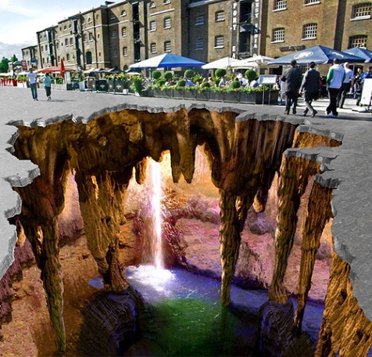
- Anti-graffiti
Some people consider it art, others think it is pure vandalism. The engineers at the police department thought of a way to fight graffiti artists. Explain in your own words how their system works.
……………………………………………………
……………………………………………………………………………………………
……………………………………………………………………………………………
Their system is rather futuristic and even nowadays governments have to think of other ways to fight graffiti. Have a look on the internet and find two methods that are being used to fight graffiti. Explain in your own words how they work.
1. ……………………………………………………………………………………………
2. ……………………………………………………………………………………………

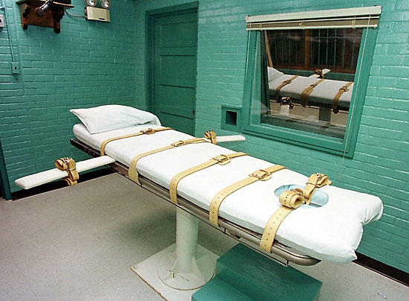
- Death penalty
At one point, Frank finds evidence that had been lost in a certain case. The suspect in that case had been found guilty and he received the death penalty. If the missing piece of evidence had been found earlier on, it could have been proved that the man was innocent.
The death penalty still is topic of heated debate and many countries still use the death penalty to punish criminals.
Use the internet to answer these questions.
- How many countries still use the death penalty? ………………………… countries.
- How many people were executed in 2012? ………………………… people.
- How many people were executed in 2013? ………………………… people.
- Which three countries were responsible for most of the executions in 2013?
…………………………………………………………………………………………
- What country keeps its records regarding the death penalty a secret?
…………………………………………………………………………………………
- There are six methods that are still being used to execute prisoners on death row. What are these methods?
…………………………………………………………………………………………
…………………………………………………………………………………………
- Look on the internet for two arguments in favour of the death penalty.
1…………………………………………………………………………………………
2…………………………………………………………………………………………
- Look on the internet for two arguments against the death penalty.
1…………………………………………………………………………………………
2…………………………………………………………………………………………


